**Course Joining Instructions**

|  |  |
| --- | --- |
| Course Title | **1 Day Lean Management Workshop** |
| Commencement Date | **Date TBC** |
| Please Arrive | **07:45 for 08:00 Start**  Course ends 16:30 |

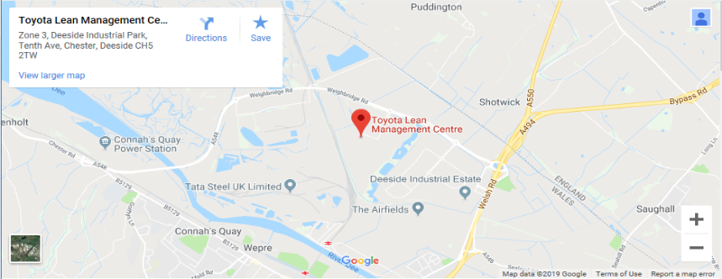**Toyota Lean Management Centre** Toyota Motor Manufacturing (UK) Ltd Zone 3 Deeside Industrial Park Tenth Avenue, Deeside Flintshire CH5 2TW

TLMC: +44 (0) 1244 282 135

Reception: +44 (0) 1244 282 121

|  |  |
| --- | --- |
| Site access & Parking  Barrier  Parking | Visitor parking is located in front of reception. (Follow reception sign)  The parking area is accessed through a security barrier. Please press the security call button and inform them you are attending a TLMC workshop.  **Please Note :- Access to our plant is via a one way system, please ensure you follow the signs when leaving our facility**. |
|  | EV Charging points are available on request.  Toyota UK are committed to supporting charities. **A charge of £5 up to the first hour and £10 for visits greater than 1 Hour is payable by cash with all proceeds going to our charitable trust.** |
| Transfers & Taxi | We recommend pre-booking your airport transfers before arrival. This will be significantly cheaper and avoids delays. We advise you pre-book.  [KingKabs | Taxis - Chester and Ellesmere Port's leading taxi company](https://www.kingkabs.co.uk/) 01244 343434  [Deeside Taxis | Cresta Cars](https://crestataxis.co.uk/deeside-taxis/) 01244 667788 |

|  |  |
| --- | --- |
| WiFi | Wi-Fi is available for visitor use. |
| Wellbeing | Throughout the workshop we will be spending periods of time out on the shop floor sharing information and observing processes, please let us know if for any reason this may be physically difficult or concerning for you. |
| Safety Shoes | Safety shoes are required for access to the shop floor.  We have a supply, but guests may be more comfortable if they can bring their own steel toe capped shoes. |
| PPE | Visitors will be issued with a helmet, safety glasses, ear plugs and a hi-vis vest. If guests will be unable to wear any of these please contact us to discuss alternate arrangements. You may bring your own PPE if this will improve your comfort. Shorts are not permitted. |

|  |  |
| --- | --- |
| Catering | We provide refreshments and lunch as part of our courses.  If you have any dietary requirements, please notify us at least one week prior so that we can ensure all guests’ needs are met. |
| Equipment | Phones and tablets are welcome on site but photography is not permitted in production areas. We will provide you with a pen and notebook for recording your observations. |

If you require any further information or need to notify us of any requirements please contact us at [tmuk.tlmc@toyotauk.com](mailto:tmuk.tlmc@toyotauk.com)



**Local Hotels**

The following hotels have previously been popular with our guests, there are many hotels within 30 minutes of the plant.

|  |  |
| --- | --- |
| Chester Racecourse  Chester  CH1 2LY | [www.ihg.com](http://www.ihg.com)  Tel: 01244 327 905  Travel time to plant, by car: 20 minutes  Parking: Free  Gym: None  Breakfast: Included  Corporate rate: £78 per night use corporate rate code 954409548 |

|  |  |
| --- | --- |
| Chester  CH1 2BD | [www.ihg.com](http://www.ihg.com)  Tel: 01244 899 900  Travel time to plant, by car: 22 minutes  Parking: £12.00 per day  Gym: Included  Breakfast: Available for purchase  Corporate rate: from £110 per night use corporate rate code 954409548 |

|  |  |
| --- | --- |
| St. David’s  Ewloe  CH5 3YB  **Chester 8 miles** | [www.villagehotels.com/VillageDirect](http://www.villagehotels.com/VillageDirect)  Tel: 01244 560 640  Travel time to plant, by car: 12 minutes  Parking: Included in corporate rate.  Gym: Included in corporate rate.  Breakfast: Included in corporate rate.  Corporate rate: £74 per night use code TYOTA  Cancelation: Free until 7pm the day before arrival  You will need to click on “more pricing options” and scroll to the bottom of the available rates, this rate appears at the bottom of the list after higher priced options. |

|  |  |
| --- | --- |
| Wirral  CH66 9PB  **Chester 7 miles** | [Craxton Wood – Discount Link](https://eur01.safelinks.protection.outlook.com/?url=https%3A%2F%2Fbe.synxis.com%2F%3FHotel%3D2322%26Chain%3D23176%26arrive%3D2024-01-04%26depart%3D2024-01-05%26adult%3D1%26child%3D0%26promo%3D001608601&data=05%7C02%7CNick.Pearn%40toyotauk.com%7C8a26b4f5097746af18fe08dc1036e554%7C52b742d13dc247acbf03609c83d9df9f%7C0%7C0%7C638403075169901469%7CUnknown%7CTWFpbGZsb3d8eyJWIjoiMC4wLjAwMDAiLCJQIjoiV2luMzIiLCJBTiI6Ik1haWwiLCJXVCI6Mn0%3D%7C3000%7C%7C%7C&sdata=XWU1lqKYLYBG5XBzMtQNfXSXT75ItClcdZnac%2FtSkyU%3D&reserved=0" \o "Craxton Wood)  Tel: 0151 347 4000  Travel time to plant, by car: 12 minutes  Parking: Included in corporate rate.  Gym: Included in corporate rate.  Breakfast: Included in corporate rate.  Corporate rate: £72 per night no code required when using the above link.  Cancelation: Free until 2pm on day of arrival  This hotel releases rooms at 2pm unless booking is guaranteed by credit card or written confirmation. |