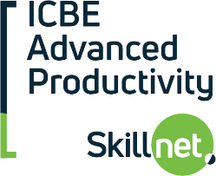 |  | 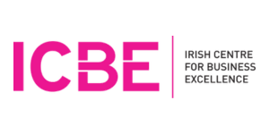
From AI Curiosity to AI Capability in just 4 weeks
A practical cross-functional programme in Data Analytics, AI and Agentic AI

Many organisations need people who can identify where data and AI create real value, ask the right questions, evaluate outputs properly, apply governance from day one and use it without putting their organisation at risk. This practical, mentored programme takes participants from classical data analytics to probabilistic AI and Agentic AI in a structured, business focused way.

Who is it for?  Operations, engineering, manufacturing, R&D and business professionals. Technical specialists who want stronger business and governance context. Managers and functional leads exploring where AI fits.  Programme Format  Duration: 4 days of effort over 4 weeks  Schedule: Working day friendly - no evenings, no weekends  Delivery: Live Online and Recorded, Mentored  Delivered by: Dave Clarke, Clarke Analytics  Start Dates:  Enquire for upcoming dates and in-company delivery options | What participants will gain  By the end of the programme, participants will be able to:  - Understand the difference between deterministic, probabilistic and agentic AI  - Match business questions to the right analytic approach and level of human oversight  - Understand how data, people, process and architecture fit together in real AI initiatives  - Evaluate AI-generated outputs for accuracy, faithfulness and practical usefulness  - Apply governance-first thinking - ethics, data quality, EU AI Act, responsible AI  - Contribute to a real-world collaborative data and AI project

Not just another AI course. Here’s why.
🎯  Practical, not hype  Real business application, not vague AI awareness | 👥  Built for mixed teams  Business and technical participants learning together | 📊  The full AI journey  Classical analytics → probabilistic AI → agentic AI
🛡️  Governance built in  Ethics, trust and responsible AI woven throughout | ☀️  Daytime, 4 weeks  Manageable commitment that fits the working day | 🎓  University-grade  Same content as accredited ATU and MTU programmes, delivered by Dave

Why this matters now  This programme helps organisations build real data and AI capability by helping participants:  - Identify where AI creates real business value  - Connect AI to real operational questions  - Assess whether outputs are trustworthy  - Choose the right level of human oversight  - Use AI without adding risk to the organisation | Learn from an industry expert  Led by Dave Clarke, Consultant Data Scientist with 30 years’ experience across multinationals, SMEs and academia.  Dave delivers accredited programmes at MTU and ATU, bringing the same rigour to this focused ICBE programme. |  | Subsidised course fees available  Grant-aided by ICBE Advanced Productivity Skillnet. Eligibility criteria apply.  Places are limited. For more information contact:  kate@icbe.ie
Find out more on www.icbe.ie |  | 